**Wireframe Document**

News Article Sorting

**Homepage**

We can see a form where user can paste news article and user can click on “Predict” button to see news article category.

1. First thing user will see is a pop-up window on the Homepage which will ask for User Inputs. User will see a form in which user can paste news article.

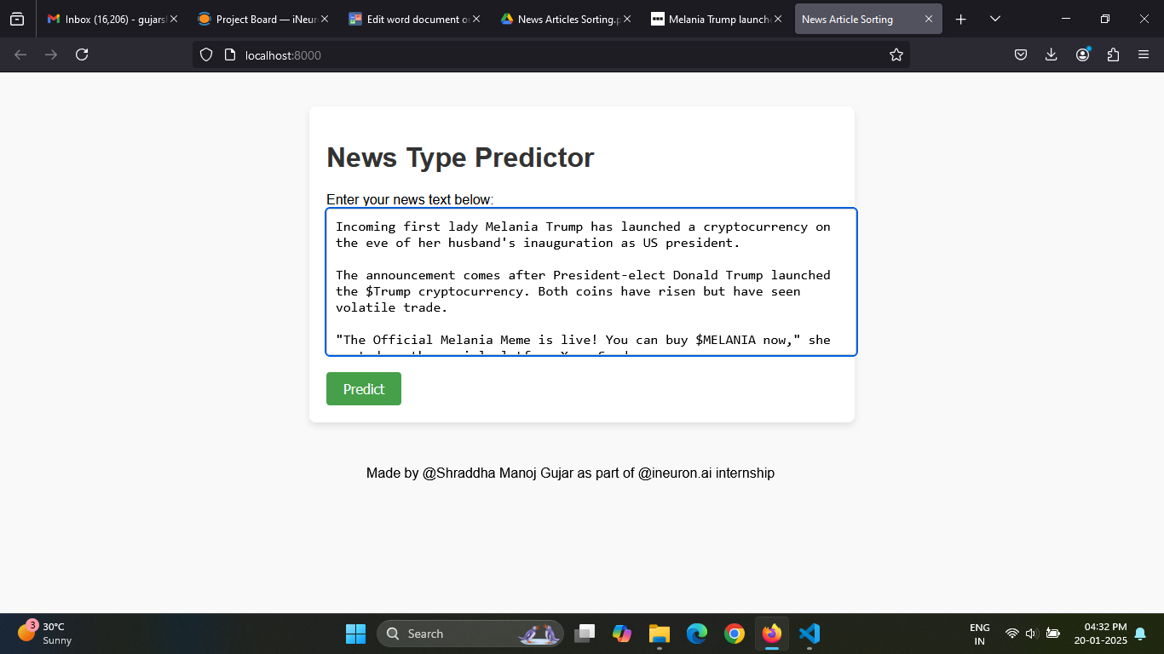

**Prediction**

1. The User will see a output of News Article Category.

